C 1 First Palindromic String 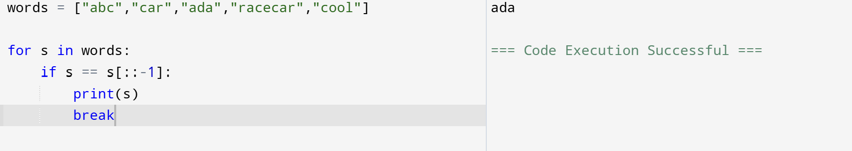
2 Sum of Squares of Distinct Counts
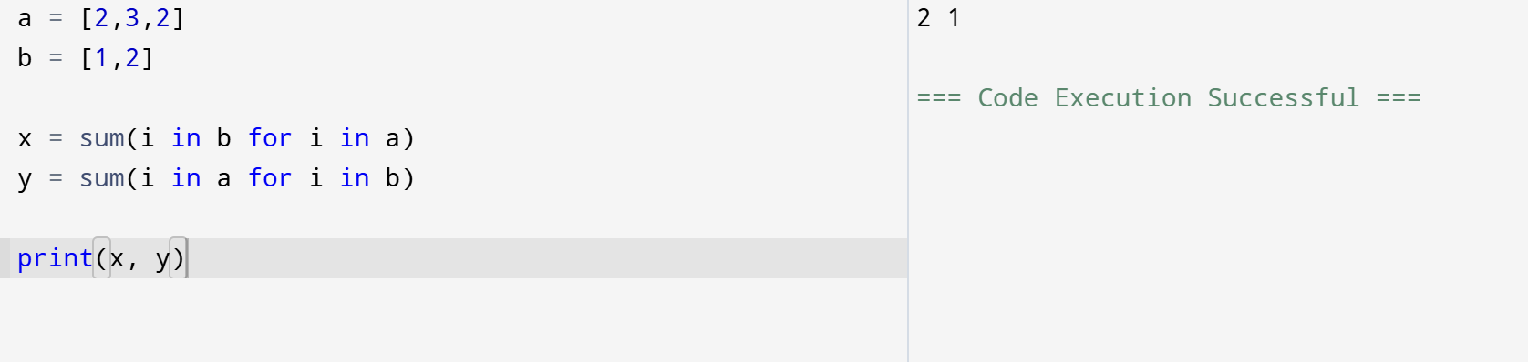
3 . Sum of Squares of Distinct Counts
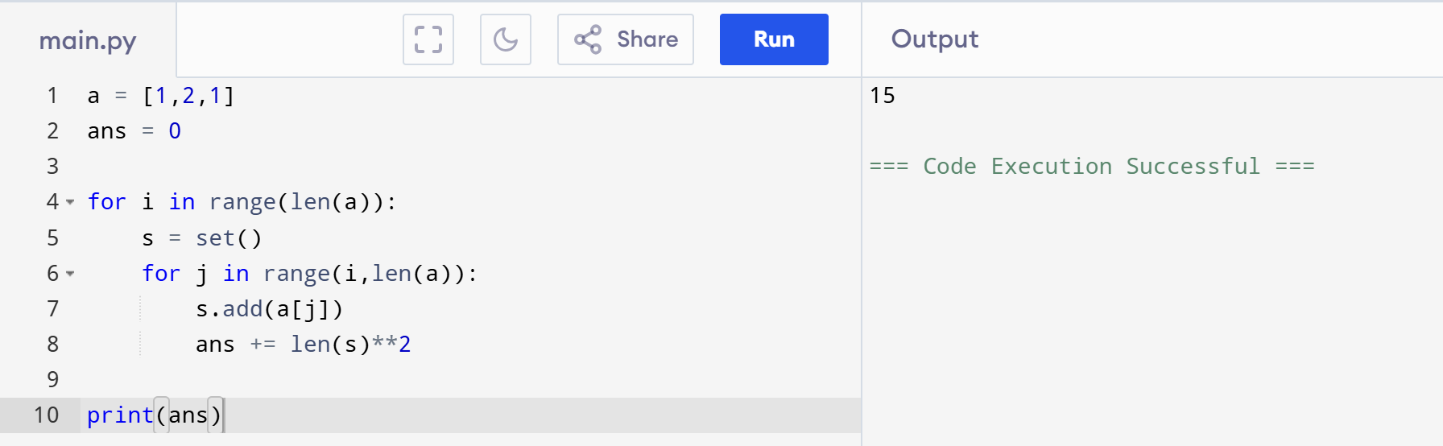

4. Sum of Squares of Distinct Counts
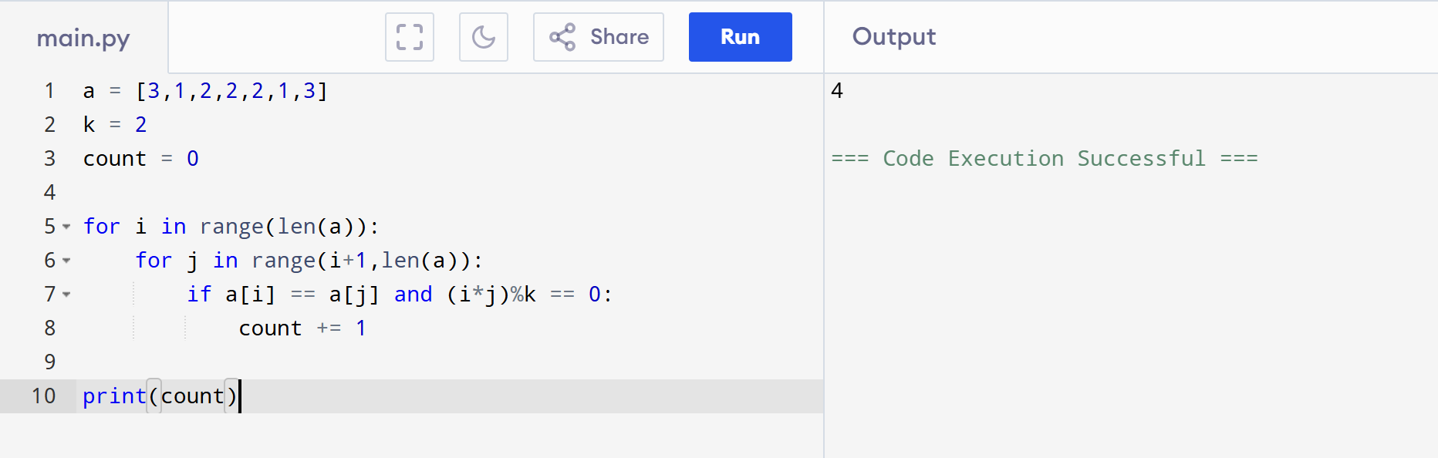

5. Find Maximum
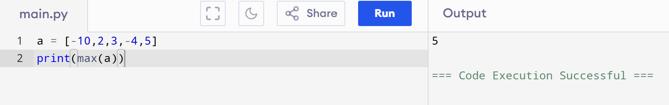

6. Sort and Find Maximum
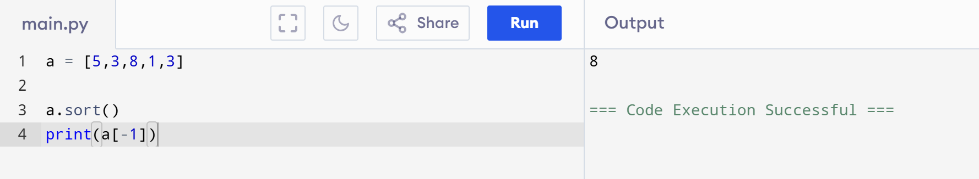
7. Unique Elements
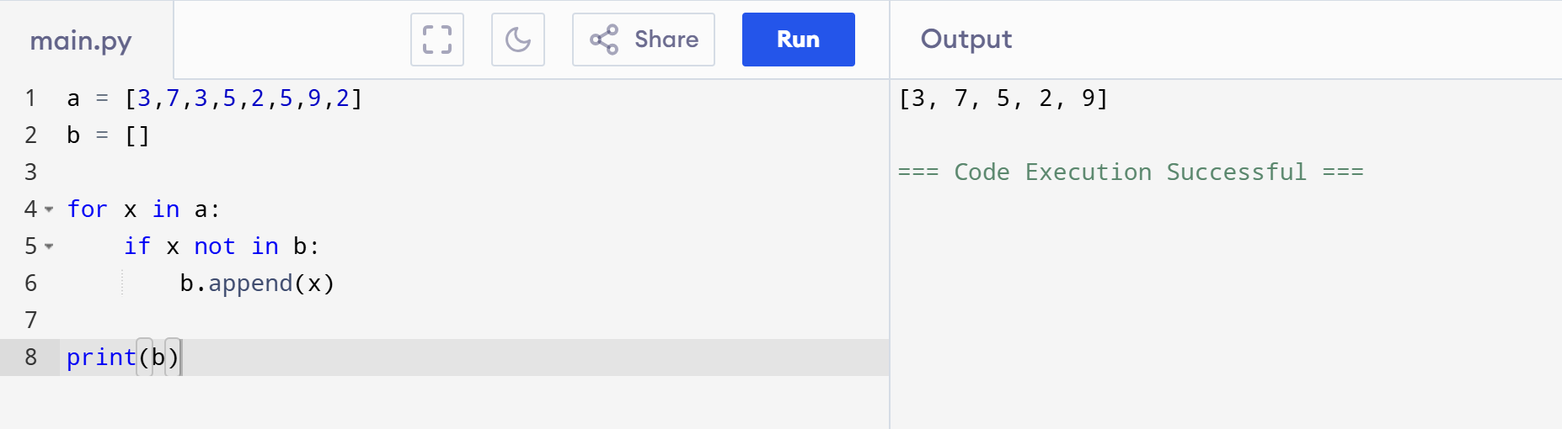
8. Bubble Sort
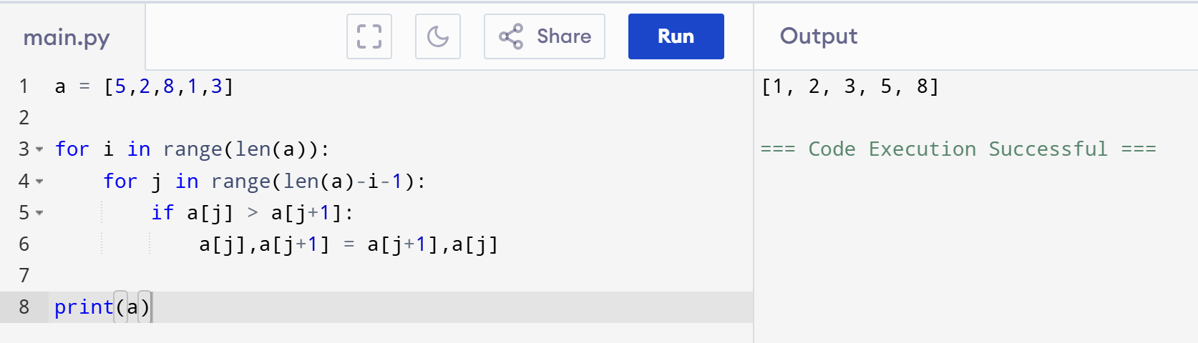

9. Binary Search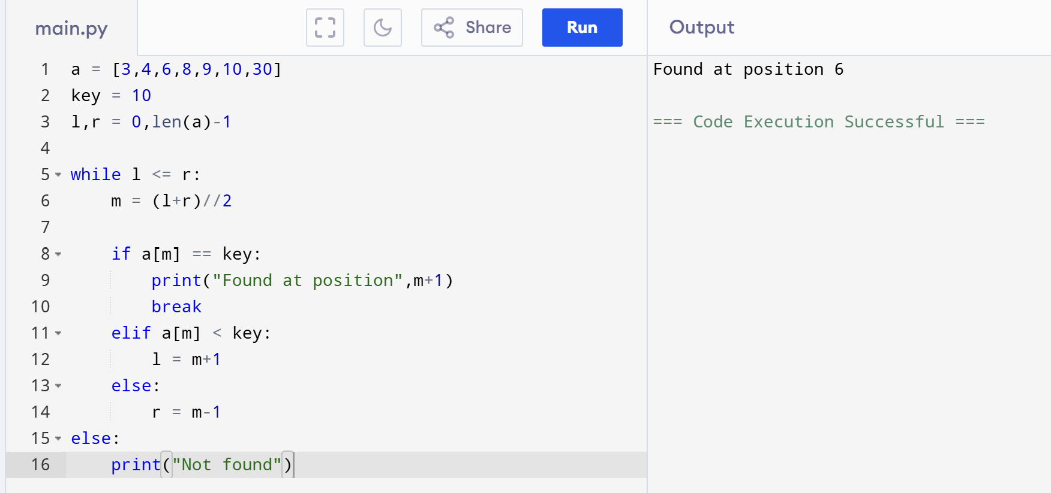
10. Merge Sort — O(n log n)
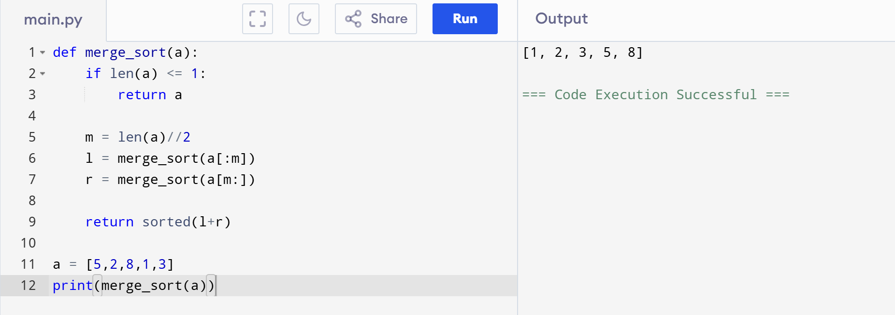
11. Number of Ways to Move Ball Out
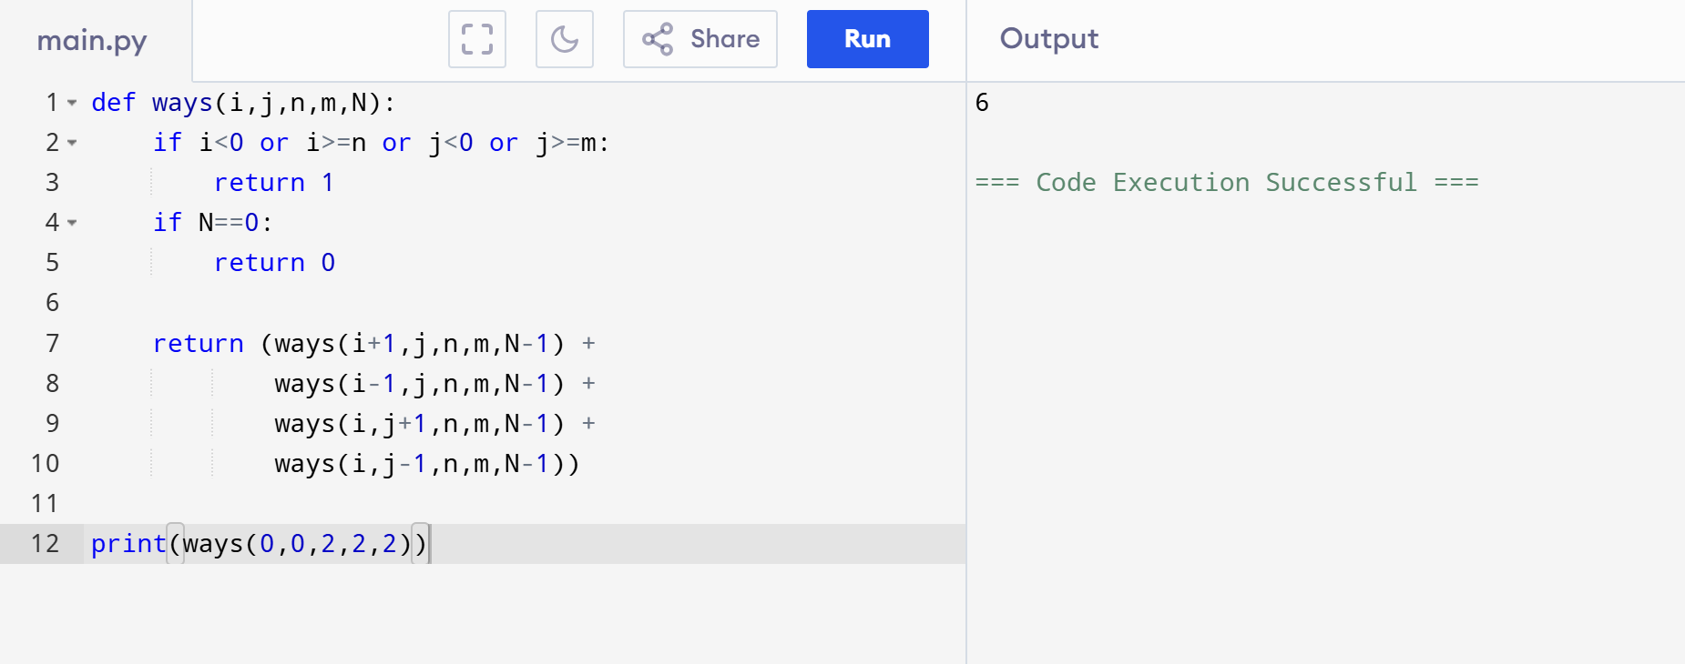
12. House Robber — Circular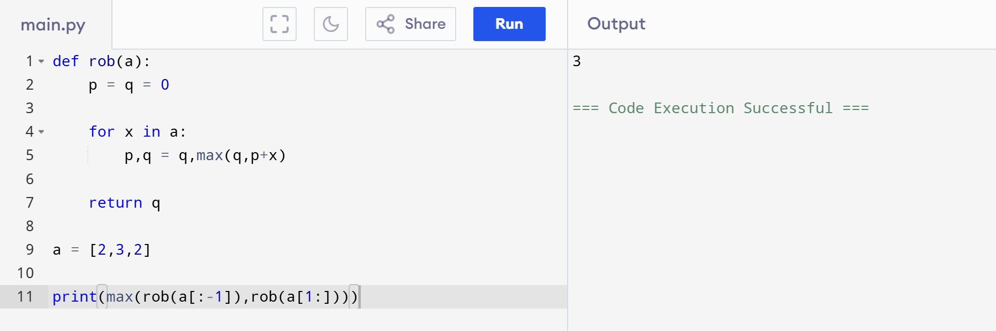
13. Climbing Stairs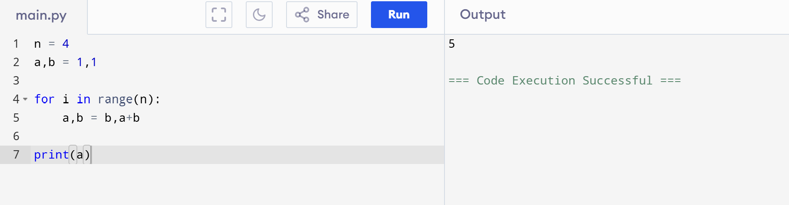
14. Unique Paths
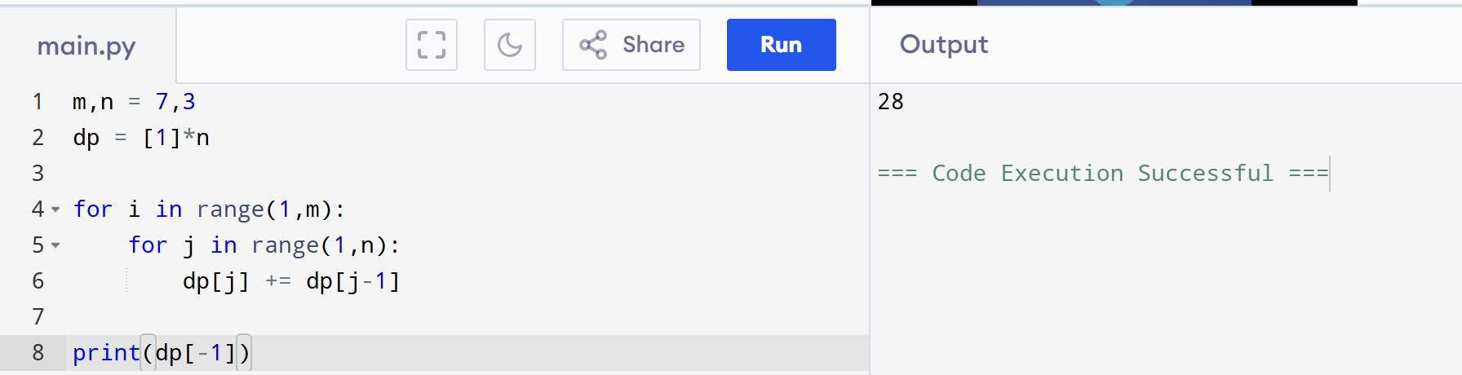
15. Large Groups
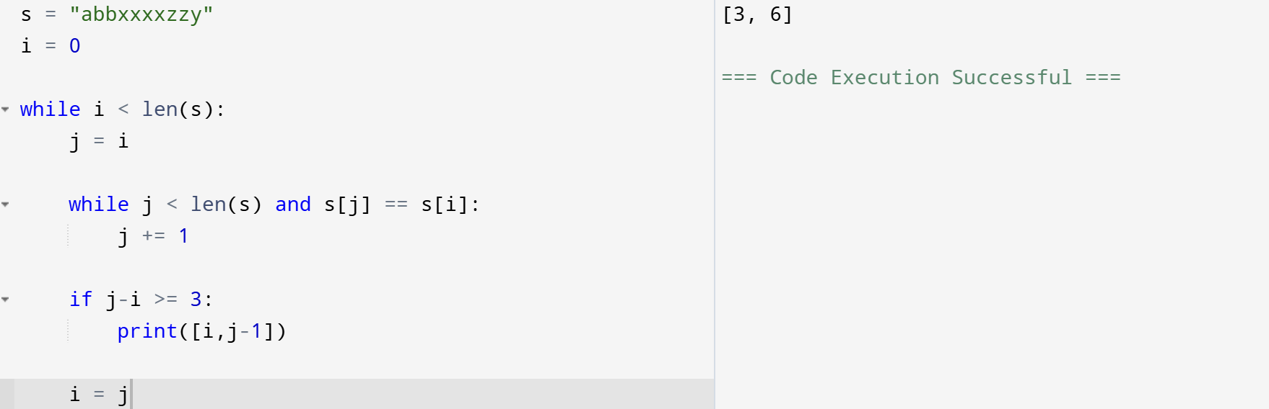

16. Game of Life
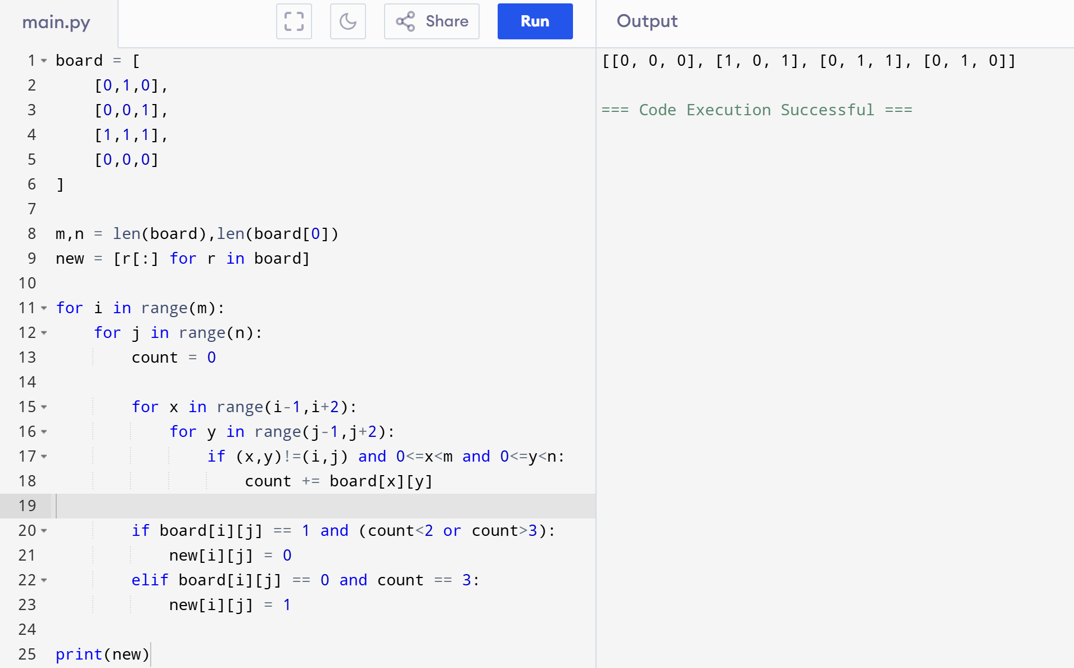

17. Champagne Tower
